Information Retrieval – Assignment 8 Screenshots

# Initial Output and plot after adding formulae for Precision and Recall



# mAP and R-precision

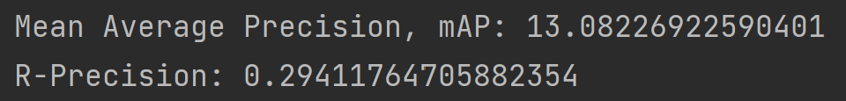

# Eleven-Point Interpolated Precision-Recall Graph

ROC curve

